**Instructions for Accessing the “Workstation” Virtual Machine via GUI**

After reserving your POD and signing into “Kiosk” as you have been, begin with these steps:

1. 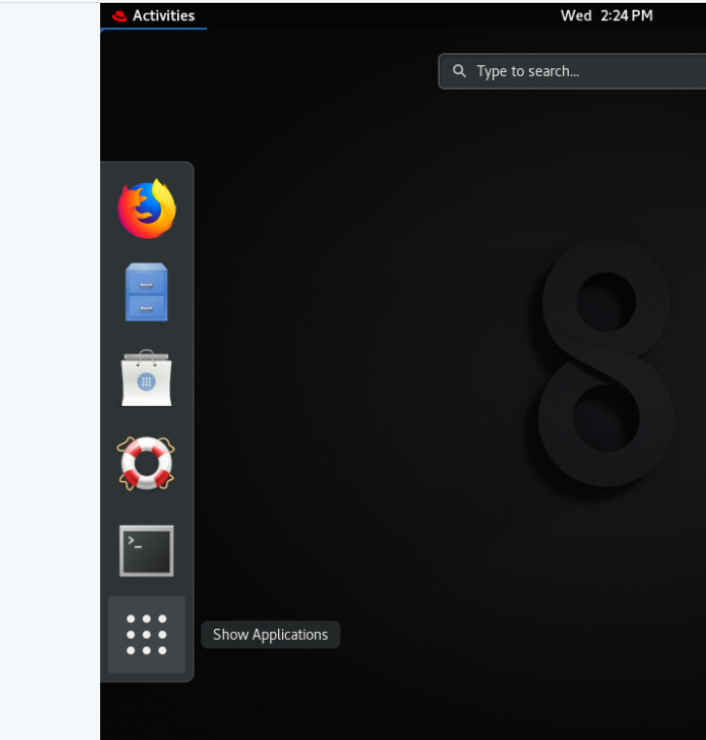Click “**Activities**” in the top left corner, then click the icon at the very bottom that resembles a square with 9 dots:
2. A graphical menu with several options should appear:

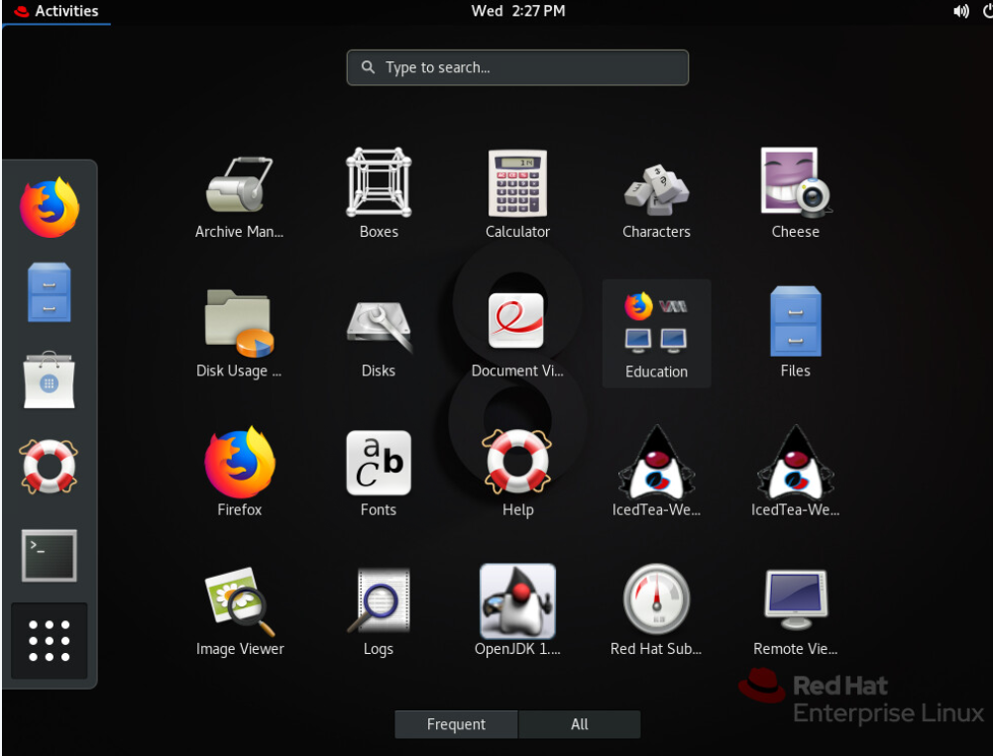

1. While hovering inside this window, scroll down to the second page until you see “**Virtual Machine Manager**”. *This will be the very last option you can select.*

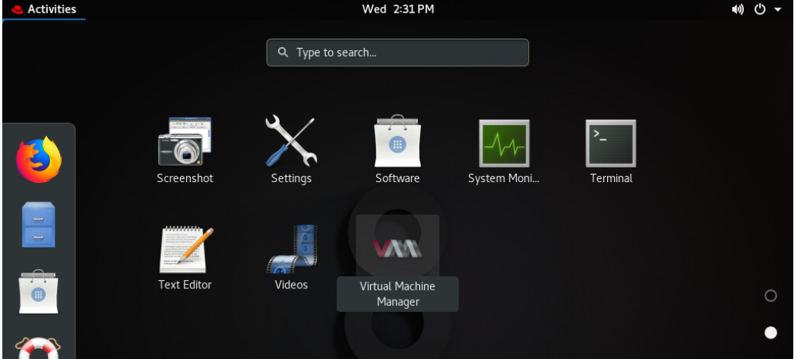

1. Double-click “**Virtual Machine Manager**”

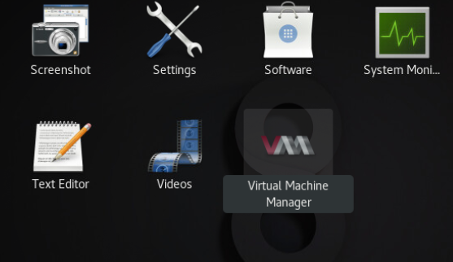

1. The following window will appear:

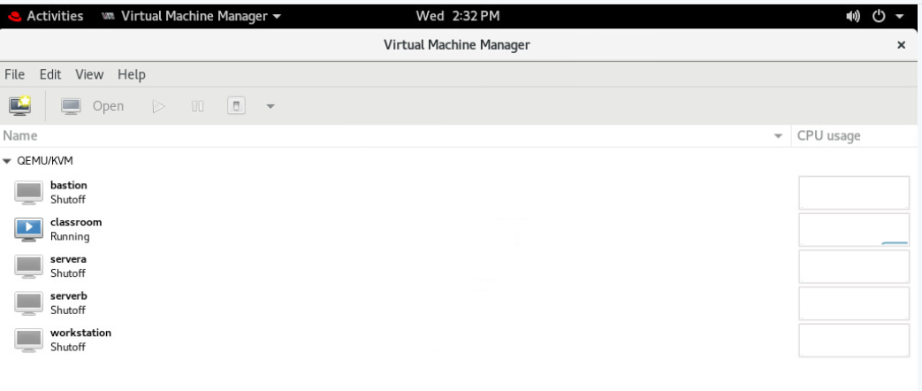

1. Right-click each machine (with the exception of “classroom” which is already running), beginning with “**bastion**”, and select **Run** to power on each machine.

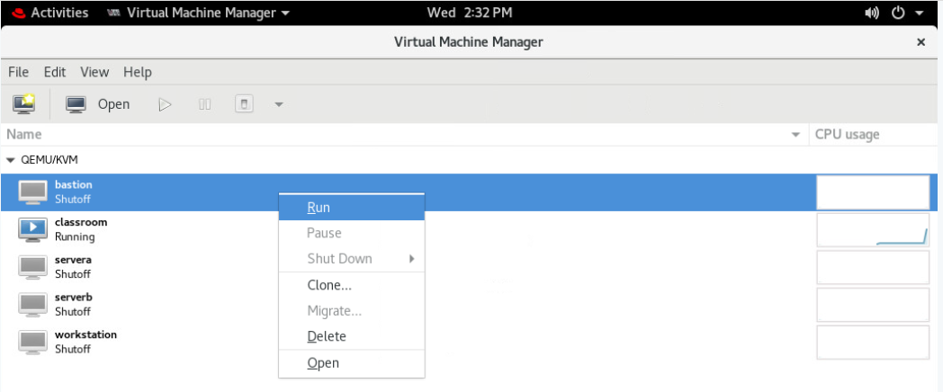

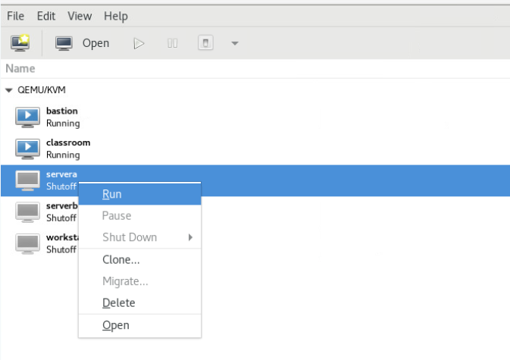

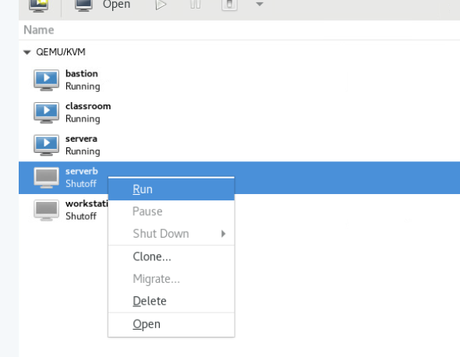

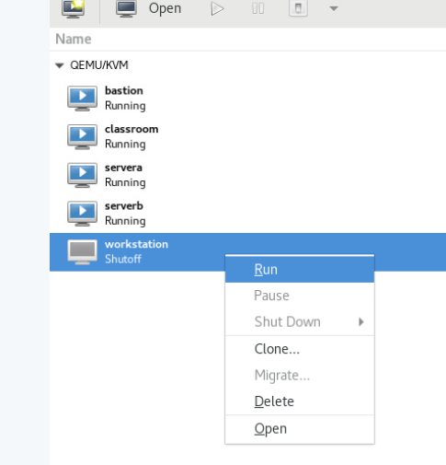

1. Once all machines are running, right-click the “**Workstation**” machine and select “**Open**”.

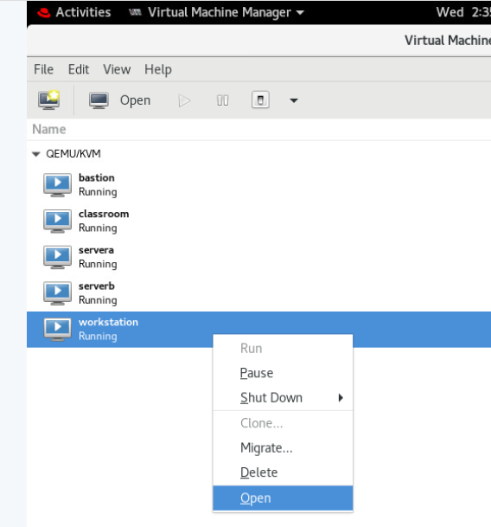

1. A screen will appear showing the student user. Log in with the password “**student**”. *Selecting the icon in the top right corner will change your view to Full Screen.*

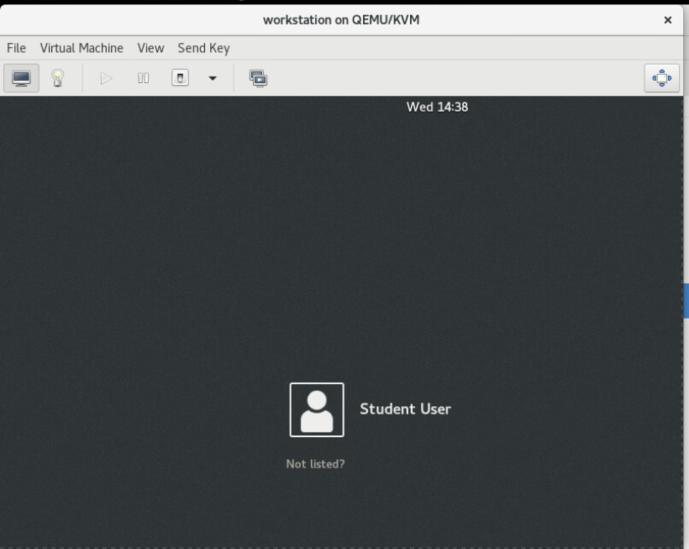

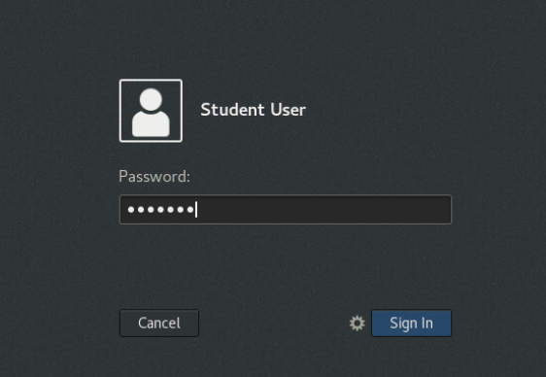

1. Once you log in, you are brought to a blue screen, similar to what you’re used to seeing, with “Activities” in the top left.

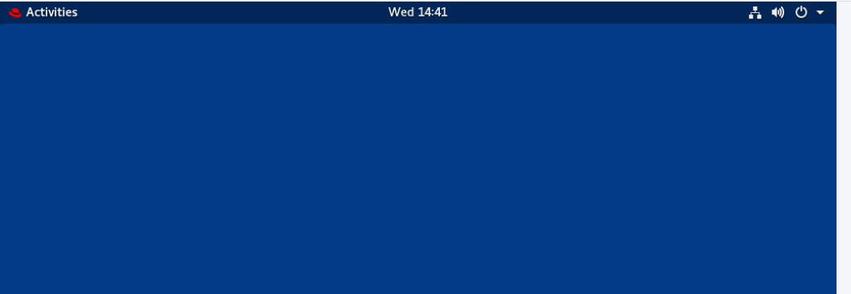

1. Select “Activities” -> “Terminal”. Now you are ready to begin!

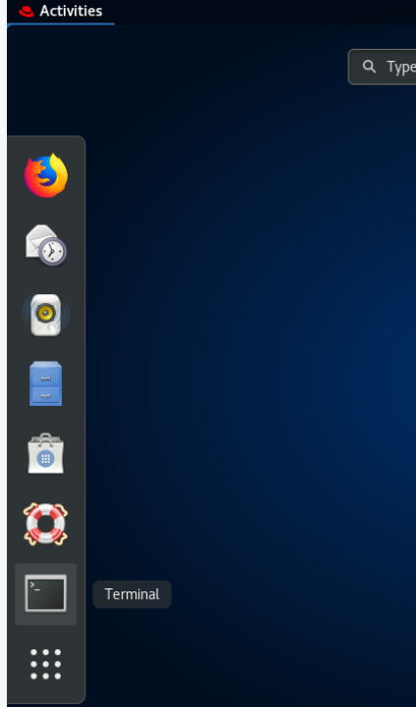

**IMPORTANT!!!**

* **You do not need to run “rht-vmctl start all” since we already powered them up manually.**
* **Do not issue the “ssh student@workstation” command. We do not need to SSH into the account, since we now logged in to the machine.**